Quarterly Report – Public Page

Date of Report: 3rd Quarterly Report, June 37, 2025
Contract Number: 693JK32410001POTA
Prepared for: Government Agency: DOT and Co-funders
Project Title: Monitor Active Vapor Corrosion Inhibitors
Prepared by: Pipeline Research Council International (PRCI), Inc.
Contact Information: Janie Norton, jnorton@prci.org 703-205-1600 ext: 105
For quarterly period ending: June 30, 2025

1: Items Completed During this Quarterly Period:

Item # | Task # | Activity/Deliverable | Title | Federal Cost | Cost Share
2 | 1 | Literature review with focus on the VCI monitoring and replenishment | Summary of the literature review | $2,859 | $2,859
5 | 2 | Develop test matrix for determining VCI effective concentration | Test matrix summary to be included in the quarterly report | $4,560.5 | $4,560.5
9 | 2 | Order materials and supplies to start laboratory work | Summary to be included in the quarterly report | $29,969 | $29,969
15 | 5 | 3rd quarterly status report & project management | Submit 3rd quarterly report | $6,609.84 | $6,609.84

2: Items Not Completed During this Quarterly Period:

Item # | Task # | Activity/Deliverable | Title | Federal Cost | Cost Share
4 | 1 | Tank operator survey on effectiveness monitoring and replenishment plans | Summary to be included in the quarterly report | $4,560.5 | $4,560.5
6 | 2 | Develop a sampling plan to measure VCI effective concentrations in the VCI treated tanks | Sampling plan summary to be included in the quarterly report | $4,886.25 | $4,886.25
7 | 3 | Develop a test matrix for determining minimum VCI non-effective concentrations | Test matrix summary to be included in the quarterly report | $4,560.50 | $4,560.50
8 | 3 | Start escape of the VCIs from the large-scale experiments | Summary of starting the VCI escape to be included in the quarterly report | $10,424.00 | $10,424.00
11 | 2 | Start laboratory tests for determining VCI effective concentrations | Summary of the laboratory tests to be included in the quarterly report | 16,287.50 | 16,287.50
12 | 2 | Collect field sand samples and data from VCI-treated tanks | Summary of the samples and data to be included in the quarterly report | 16,287.50 | 16,287.50
13 | 3 | Start laboratory tests for determining minimum VCI non-effective concentrations | Summary of the laboratory tests to be included in the quarterly report | 12,500.00 | 12,500.00
14 | 3 | Collect field sand samples from VCI-treated tanks to determine VCI escape profile | Summary of the samples and data to be included in the quarterly report | 12,500.00 | 12,500.00

The project is behind schedule due to contracting delays between PRCI and BSRA.

3: Project Financial Tracking During this Quarterly Period:

Note that this chart reflects Federal share only:

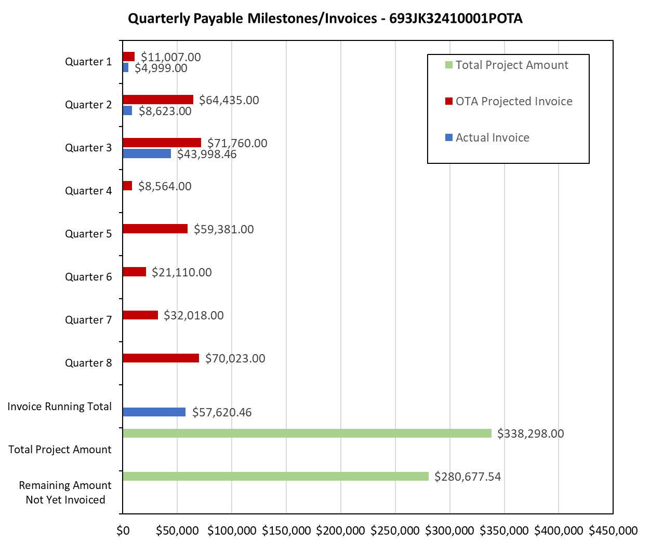

4: Project Technical Status –

Item 2, Task 1 ⎯ Literature review with focus on the VCI monitoring and replenishment, Summary of the literature review: The following is the summary of the literature review.

Soil-side corrosion of aboveground storage tanks (AST) is a significant corrosion problem globally, as it can shorten the operational lifespan of these tanks. Corrosion on the underside of the tank bottom plates leads to metal degradation and perforations, resulting in the loss of primary containment. Consequently, this can cause product loss, expensive repairs, and, most importantly, the release of hazardous chemicals, which can be harmful to both the environment and human health. Different techniques were used by tank operators to mitigate the soil side corrosion. One of the emerging techniques is the use of vapor corrosion inhibitor (VCI). VCI typically possess a vapor pressure higher than 10⁻⁵ mm Hg and can easily volatilize to access and protect hard-to-reach areas of a metal surface are referred to as volatile corrosion inhibitors (VCIs) (Gangopadhyay & Mahanwar, 2018).
In new construction, the VCI is reported to be added to the sand as a dry powder before the steel bottom is installed. Dry powder may be added at a level ranging from 0.1 – 0.2 kg / m² to 1‐2 kg/m². VCI is typically added as a slurry (e.g., 5% aqueous solution) from one point in a retrofit application. The slurry continues to be added until liquid appears at a port at the opposite side of the tank, suggesting that the entire sand layer may be filled with the liquid. There are also reports of a “dry ring system” installed around the perimeter of the tank, whereby the VCI is drawn into the tank bottom area via pressure differentials caused by daily temperature swings (Ellor & Kuespert, 2018).
Sherwani et al. (Sherwani, 2022) used VCI to reduce soil side corrosion of an out of service tank. Total 8 electrical (ER) probes were used to monitor the corrosion rate. It was evident that all probes except one continued to show low corrosion rate after 120 days of post injection of VCI. VCI was applied to the tank using a methodology where fogging of VCI powder was introduced into the interstitial space under the tank. Total sixty-eight (68) fogging points were drilled of 0.75-inch diameter and the powder were fogged at a rate of 1.5 kg per minute. All the points were patched with circular metal plate 10 cm in diameter and same thickness of bottom plates after fogging. Similarly in another research (Whited, Yu, and Tems, 2013) VCI was used to reduce the soil side corrosion of an above ground crude oil storage tank. VCI was injected into the air gap between the sand pad and the underside of the tank bottom within 6 meters of the tank shell during a scheduled maintenance outage. Originally, a combination of two methods for delivering both liquid and powder VCI was specified. The revised plan, however, involved injecting only VCI powder through 50 x 20 mm threaded temporary injection ports in the floor plates. This design addressed both the 6-meter perimeter of the floor plate area and the interior floor plates where corrosion was identified in the MFL Report. Pneumatic equipment was utilized to efficiently disperse 9.5 kilograms of VCI powder through the temporary injection ports beneath the floor plates, covering a minimum distance of 10 meters in all directions. Once the VCI application was completed, steel plate patches were welded over each port. ER probes were used to evaluate the VCI effectiveness. The ER probe measurements were obtained over the two months prior to the VCI application on a weekly basis. After the VCI application the measurements were obtained on a weekly basis for seven months. It was concluded that VCI application significantly reduced the corrosion rate.
VCI effectiveness was also investigated for a as-built test tank (Adelakin, Math, & Lindemuth, 2017). Conduits were built in the sand base underneath the second bottom of a double steel bottom tank. Liquid VCI was injected, and the sand base was flooded to the underside of the tank bottom through the conduits. ER probes were also installed within the conduits to collect data at periodic interval. Application of VCI showed reduced corrosion rate. It was concluded that stable conditions may take over 12 months and as long as 24 months to achieve the required effectiveness. Another research investigated the effectiveness of VCI under severe corrosive environment (Shukla, Fuentes, Nordquist, Wiersma, & Pederson, 2024). In this research VCI was applied through the floor for out of service tanks and through the sand pad for in service tanks. It was observed that VCI performance is robust and not compromised due to high chloride levels, such as 300 ppm or more. Moreover, it was concluded that the through-the-floor VCI delivery method is more beneficial compared to the through-the-sand-pad method when tank pad corrosivity is elevated. After 7 years of service a refinery experienced its first tank failure due to soil side corrosion (Ghafri, Nair, Abri, & Shibli, 2018). VCI was applied to mitigate the soil side corrosion in this research. The VCI powder was fogged through seven injection ports of the tank floor. Injection tubes were installed by core drilling into the bitumen/Concrete Ring foundation. VCI Slurry was injected through distributed perforated injection pipes. The pipes are embedded within the sand pad and ensure effective and even distribution of the slurry. ER probes were installed to evaluate the effectiveness of the VCI. It was concluded that VCI can extended the service life of AST.

References:

Adelakin, T. K., Math, S., & Lindemuth, D. (2017). External Corrosion Protection of Underside Bottom of above Ground Storage Tank Using Vaporized Corrosion Inhibitors. CORROSION 2017. New Orleans: NACE International.

Ellor, J. A., & Kuespert, E. (2018). AST Corrosion Control and Monitoring with VCI Applications. CORROSION 2018 (p. 13). Phoenix: NACE International.

Gangopadhyay, S., & Mahanwar, P. A. (2018). Recent developments in the volatile corrosion inhibitor (VCI) coatings for metal: a review. Journal of Coatings Technology and Research, 15, 789–807.

Ghafri, A. A., Nair, J. R., Abri, N. A., & Shibli, L. A. (2018). Successful Implementation of a Corrosion Management Strategy by Online Injection of Vapor Phase Corrosion Inhibitors to Extend Storage Tank Floor Life. CORROSION 2018. Phoenix.

Sherwani, M. A. (2022). Use of Vapor Corrosion Inhibitor for Tank Bottom Protection. AMPP 2022. San Antonio.

Shukla, P. K., Fuentes, R. E., Nordquist, A., Wiersma, B. J., & Pederson, I. (2024). Effectiveness of Vapor Corrosion Inhibitors under Elevated Chloride Conditions for Aboveground Storage Tank Application. AMPP 2024 (p. 14). New Orleans: AMPP 2024.

Whited, T., Yu, X. A., & Tems, R. (2013). Mitigating Soil-Side Corrosion on Crude Oil Tank Bottoms. CORROSION 2013 (pp. 1-12). Orlando: NACE International.

This item links to items 2 in Attachment 1 Team Project Activities. This item links to item 2 in Attachment 2 Project Deliverables.

Item 5, Task 2 ⎯ Develop test matrix for determining VCI effective concentration, Test matrix summary to be included in the quarterly report:

The test matrix to determine the VCI effective concentration is listed in Table 1.

Table 1. Test Matrix to Determine VCI Effective Concentration Through Laboratory-Scale Experiments
Parameter | Value
Salt Content | Chloride: 30 and 100 ppm  Sulphate: 15 and 50 ppm
Grain size: | ASTM C778 except sieve 20
Moisture content | 50%
VCI dosage | 10, 20, 30, 40, 50% of the recommended values
Temperature | Lab conditions, 22 C
Coupons | 1 inch diameter, A36 carbon steel, 3 coupons per test, three repeats per condition
Corrosion rate | Weight loss and pit depth measurements
Test Duration | 6 months

This item links to item 4 in Attachment 1 Team Project Activities. This item links to item 4 in Attachment 2 Project Deliverables.

Item 9, Task 2 ⎯ Order materials and supplies to start laboratory work, Summary to be included in the quarterly report: The project team has ordered several hundred coupons, ten ER probes, and plastic contains for the laboratory-scale experiments. Some of the items have been received and team is awaiting receipts of other items. The total cost of purchasing various supplies is approximately $30K, as budgeted in the proposal.

Item 15, Task 5 ⎯ 3rd quarterly status report & project management, Submit 3rd quarterly report: The second quarter meeting was held on June 12, 2025. This report satisfies this item. This item links to item 14 in Attachment 1 Team Project Activities. This item links to item 19 in Attachment 2 Project Deliverables.

5: Project Schedule –

The project is behind schedule. The project team will try to catch up as much as possible during the next quarter.

